Ivanka Stefanova-Achter
PR Manager
Tel. +498994921488
Ivanka.stefanova-achter@messe-muenchen.de
Messe München GmbH
Messegelände
81823 München
Germany
messe-muenchen.de

Munich, January 17, 2018
Press Release
Leading Edge thanks to Automation
automatica 2018 shows solutions for food and beverage, plastics and packaging manufacturers

In September 2017, VDMA increased its growth forecast for the current year for German robotics and automation from seven to eleven percent. The industry is also booming internationally. With this positive outlook and numerous innovations ready to be shown, the world's leading companies are going to meet at automatica in Munich from June 19 to 22, 2018. Visitors from industries such as food and beverage, plastics as well as packaging will find numerous innovative automation solutions and have the opportunity to exchange ideas with experts.

"Both the incoming orders as well as sales development for the current year have significantly exceeded our expectations,” Dr. Norbert Stein, Chairman of VDMA Robotics + Automation, commented on the development of the German market. "The domestic industry will record more than 14 billion euros in sales and for the first time in the year 2017 consequently reach a new record level."

The great economic importance of automation technology can also be felt on the global level: According to the International Federation of Robotics (IFR), more than 1.7 million new industrial robots will be installed in the factories all over the world by the year 2020, which will increase global inventory to more than three million units.

The above-average growth in the automation industry in the past few years is due to the rapidly growing number of variants in many production fields, a zero-error strategy required more and more frequently during processes as well as increasing cost pressure, among other things. These requirements can only be fulfilled with higher degrees of automation, increasingly powerful systems and more flexible processes.

The automotive industry and its suppliers have been the most important users of automation and robotic systems for many years. The use of automated processes in this industry segment is the most advanced, but many other sectors are also working increasingly with highly automated solutions for more efficiency and cost effectiveness. As a result, companies from the fields of plastics, foodstuffs and packaging are increasingly employing innovative automation to improve their competitive position. Compared to the pioneering automobile industry, however, these three industry sectors have some catching up to do.

The following examples from the fields of food and beverage, plastics as well as packaging show, on behalf of the entire application spectrum of automation, how intelligent system solutions implement the requirements of modern production plants.
Application examples plastics
Application examples food and beverage
Application examples packaging
Application example 1: Production of automotive assemblies made of plastic
Industry: Plastics
Company: ABB Automation GmbH

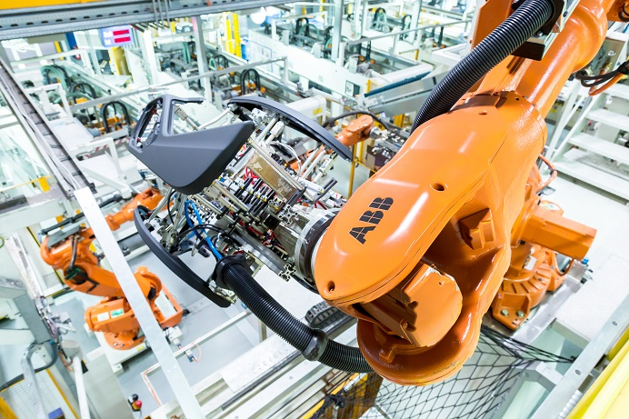
Link to photo: ABB SKI_160913-101.jpg (photo source: ABB Automation)

The automotive supplier SMP Deutschland GmbH is specialized in plastic parts for automotive interior and exterior components. In the SMP plant in Neustadt on the Danube, ABB robots handle instrument panels and door panels, among other things, in fully automated production lines that were produced by the FRIMO Group GmbH. The ABB robots are used on two levels for optimal utilization of the production area. They take plastic parts from conveyor systems, place them in a variety of processing machines, and pass them on for further manufacturing steps. For example, the three robots machine components simultaneously on a milling cell and consequently reduce total machining time. Increased path accuracy and thus improved production quality can be achieved thanks to the use of the robot type IRB 2400, which is particularly suitable for milling. In a laminating machine for door panels, the components are transferred by "handshake" by an extraction robot IRB 6650 on the middle level directly to an IRB 6620 robot on the upper level, which fits the two edge wrapping systems for the trim of the front and rear doors and consequently ensures optimal utilization of these systems. Plastic film is folded over during wrapping and fastened by joining processes to the back of the carrier part. Approximately 130 ABB robots are used in this SMP plant.

Application example 2: Production of plastic parts for medical devices
Industry: Plastics
Company: Stäubli Tec-Systems GmbH Robotics

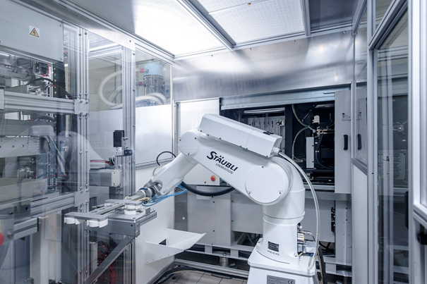
Link to photo: Stäubli_Plastibell01.jpg (photo source: Stäubli Tec-Systems GmbH Robotics)

The French manufacturer Plastibell is a recognized specialist in the manufacture of plastic parts for medical devices, diagnostic equipment and connectors, e.g., for dialysis bags. Secure control of all production steps in compliance with the most stringent hygiene requirements is one of the key requirements in the medical area, a requirement which Plastibell fulfills thanks to the use of appropriate automation and robotic systems. In this application, a Stäubli robot of type RX160 unloads an injection molding machine. To do this, the big six-axis robot withdraws two different injection molding parts in batches of four with a U-shaped vacuum gripper from the tool and makes them available for further processing. An ultra-fast and compact TX90 six-axis robot picks up the cups, consisting of lower part and lid, with its vacuum gripper and stacks them for final picking and packing activities. Both Stäubli robots already fulfill in the standard version the applicable clean room requirements at Plastibell and consequently ensure that hygienic specifications are complied with during this production step.

Application example 3: Assembling and bonding of plastic components
Industry: Plastics
Company: KUKA Roboter GmbH

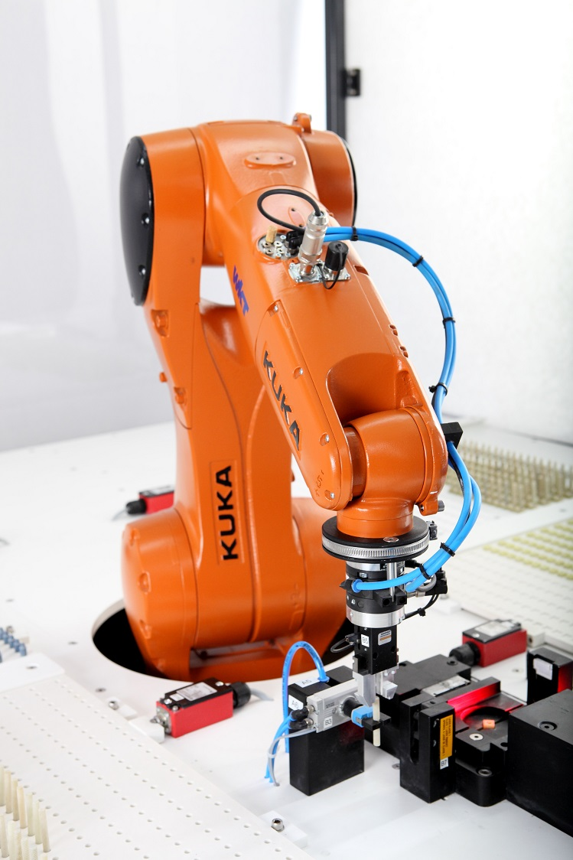
Link to photo: KUKA R 456 WKT Geeste_20.jpg (photo source: KUKA Roboter GmbH)

"Plastic instead of steel in every field of activity" is the motto of WKT Kunststofftechnik GmbH. Assembling and bonding various plastic components is at the start of each product. One necessary preparatory work step in producing a versatile plastic threaded screw for various thread sizes and lengths is the joining together of the three components nut (with square or hexagonal shape), threaded rod and washer. Because thermoset plastics cannot be welded, a special adhesive joins the components. The work steps for the manufacture of such components require optimum precision. WKT automates this task with a small robot from KUKA Roboter GmbH to reduce the error rate to zero percent and thus increase productivity.
Application example 4: Robot-based handling of beverage bottles
Industry: Food and beverage
Company: Yaskawa Europe GmbH

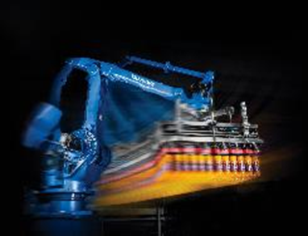
Link to photo: Yaskawa AirGrip.jpg (photo source: Yaskawa Europe GmbH)

Yaskawa has developed a gripper solution with AirGrip for robot-based handling of beverage bottles. Mounted on a Motoman handling robot, the patented tool enables secure, flexible and fast loading/unloading processes for glass and plastic bottles in crates, trays and multi-pack containers. Stable, robust rubber grip cuffs ensure a secure hold of bottle necks, even in high-speed applications without damaging the caps. The bottles are picked up using compressed air. A sorting table with optionally one or two robots rounds out the AirGrip system. It enables automated feeding both of single bottles as well as multi-packs with either 0.5, 1.0, 1.5 or 2.0 liter bottle contents. The Norwegian beverage manufacturer Roma Mineralvannfabrikk uses such an AirGrip system including sorting table successfully and was able to increase its sales by approx. 30 percent thanks to higher filling capacity. Two Motoman robot models from Yaskawa are used in this system: a 5-axle heavy-duty robot SP800 with 800 kg load and a 4-axis palletizer MPL500 with a capacity of 500 kg.

Application example 5: Inspection tasks during beverage production
Industry: Food and beverage
Company: Cognex

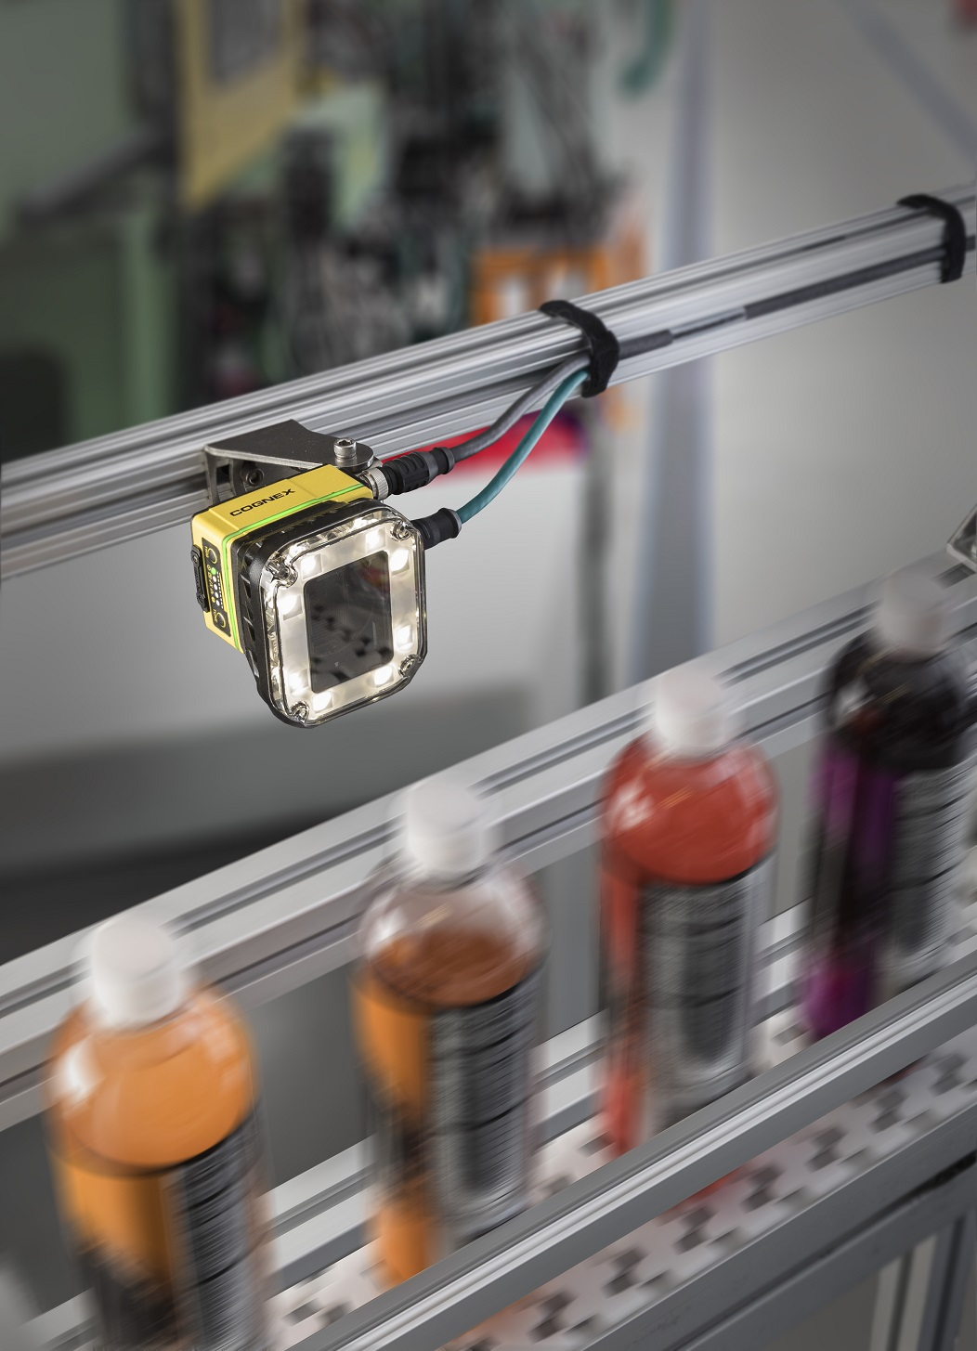
Link to photo: Cognex_VisionSystem_IS7000.jpg (photo source: Cognex Germany)

Cognex machine vision and identification systems are used by renowned manufacturers in the automation of production, packaging, handling and logistics processes. In the production of foodstuffs and beverages, they handle inspection tasks such as the examination of the caps, fill levels of beverages, OCR recognition for durability date or batch number, and verification of the integrity of security seals or correct portioning, among other things. During the portioning of food, a profile laser generates a three-dimensional image by means of triangulation and calculates the volume of portion. The data reconciliation of the expected quantity and the actual quantity then determines the output result, which is forwarded to different controllers. Via the user interface of Cognex Designer, even complex applications are simple to set up via drag-and-drop, which saves users time and costs for system design. Position detection for pick and place robots and traceability via 1D or 2D bar codes in the entire supply chain are part of the typical application fields of the vision systems, vision sensors and barcode readers from Cognex. The use of these systems ensures that consumers get only faultless food and reduces the risk of expensive recall actions.

Application example 6: Packaging foodstuffs
Industries: Food, Packaging
Company: Kawasaki Robotics

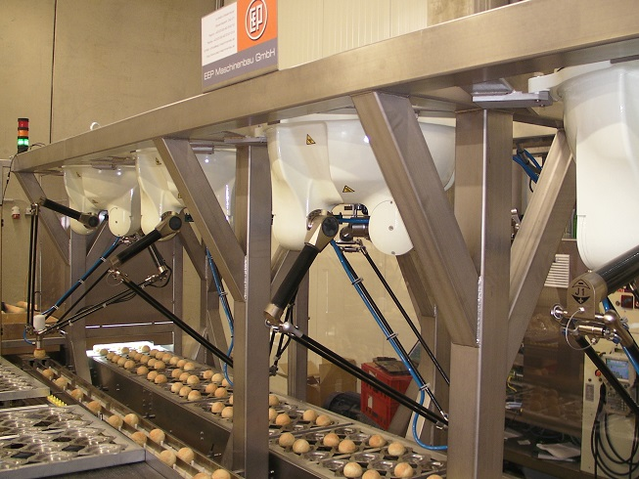
Link to photo: Kawasaki Robotics Breadpicker.jpg (photo source: Kawasaki Robotics)

The companies EEP-Maschinenbau and DI Christl have created an automation line for Eat the Ball, on which ball-shaped bread rolls designed as American footballs, soccer balls, and hockey pucks are manufactured and packaged. They first pass through a visualization system in product carriers. Information about failed or missing products detected there is transmitted to four delta robots of type YF003N from Kawasaki Robotics, which then remove the rolls from the carrier systems and place them on a conveyor chain for the next packaging processes. The carrier system and the gripping technology of the robotic system can handle all variants with their different forms (oval, round, and cylindrical) and surfaces without retrofitting. For the gripping technology of the robotic system, a high-performance vacuum system was selected with a spacious vacuum tank and multiple filtering, which also enables fast transfer cycles of just under 0.5 seconds per robot system. After additional quality controls and automated packaging steps, the packaged rolls are placed in a deep-freeze storage system. The entire system makes economical packaging possible for the products of Eat the Ball Company while at the same time ensuring the strict quality requirements in the food area thanks to the high degree of automation and flexibility.

Application example 7: Quality assurance of packaging materials
Industry: Packaging
Company: ISRA VISION AG

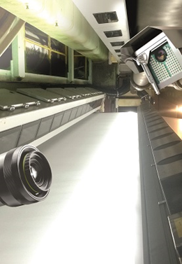
Link to photo: ISRA 672_2.jpg (photo source: ISRA VISION AG)

The Swiss packaging group Model AG automates quality assurance of its further processing with industrial machine vision systems from ISRA VISION. Because the company not only prints packaging produced in-house, but also produces packaging materials such as corrugated cardboard itself, quality assurance throughout the entire process chain represents a special challenge. PaperMASTER from ISRA VISION makes it possible for Model AG to inspect paper and cardboard for packaging. Among other things, it detects and classifies defects such as color stains, pressure deviations as well as inclusions or impurities in the paper. The solution CartonSTAR enables reliable print image control and inspection of imprinted cardboard materials. In this way, faulty cartons are reliably detected and ejected, so that customers only receive packaging materials in perfect condition. With the machine vision systems from ISRA VISION, Model AG therefore complies with customer requirements for zero-defect production and also avoids downtime during production processes, which can be caused by broken off edges or tears at a paper edge. Since the installation of these inspection systems, the number of production shutdowns at Model AG has been reduced significantly.
Application example 8: Machine vision ensures error-free aluminum containers
Industry: Packaging
Company: STEMMER IMAGING

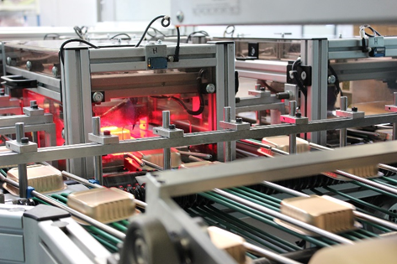
Link to photo: Leuthold_3.jpg (photo source: STEMMER IMAGING)

The Swiss company Leuthold Mechanik AG (HLM) builds systems for manufacturing aluminum containers, which are used for packaging animal feed and foodstuffs, among other things. The core element of quality assurance is machine vision from STEMMER IMAGING. Such systems produce high quality aluminum containers, which are filled later with animal feed, jams, pastry or coffee powder. The company has also already developed similar systems for completely different substances, e.g., fuel pastes or packaging for medical products such as inhalers. Aluminum is relatively expensive as a base material, and therefore the containers should be as thin-walled as possible to keep costs low. On the other hand, the danger increases with decreasing material thickness that holes can be produced during the forming process due to inclusions in the raw material or high voltages, which would make a container leaky and therefore unusable. Consequently, any defect containers must be identified and sorted out, because otherwise there is a risk that the contents spoil. Due to the high production speeds and the required 100% monitoring, this quality inspection is only possible with the help of suitable machine vision systems. They reduce the cost of the required base material and ensure error-free containers.

Application example 9: Automatic accounting for vials and ampoules
Industry: Packaging
Company: VMT Vision Machine Technic Bildverarbeitungssysteme GmbH

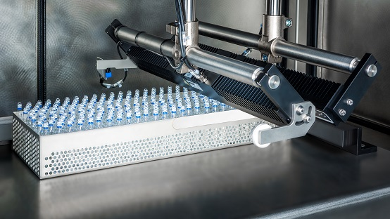
Link to photo: VMT MultiCount.jpg (photo source: VMT Vision Machine Technic Bildverarbeitungssysteme)

VMT MultiCount is a system for automatically counting vials and ampoules in medical technology and pharmaceutics. Thanks to the combination of state-of-the-art camera technologies, lighting techniques and algorithms, pharmaceutical containers with medical substances are counted safely and reliably before they are packed. The system can be used separately or integrated into production lines and is characterized by great flexibility and ease-of-use. For example, any arrangement of containers is possible and does not have to follow certain rules. The containers can have sizes from 1 ml to 100 ml and 5 mm to 50 mm diameter and be made from a wide range of materials such as plastic, transparent or colored glass as well as use differently colored caps. All measurements and results are recorded and documented. The previously required manual count procedures have been completely and reliably automated thanks to this computer-based counting system.

************************************************************************

All application examples and related photos are available here
automatica Videos
automatica Press Releases and Photos
automatica Photos and Logos
About automatica
automatica is an international trade fair for robotics and automation and the central meeting point for manufacturers and users of integrated assembly solutions, robotics, industrial machine vision and professional service robotics. With the Trend-setting topics digital transformation in manufacturing, human-robot collaboration and service robotics, automatica makes an important contribution to designing Work 4.0 at places where people bear more responsibility than ever before. At the last event in 2016, a total of 833 exhibitors from 47 countries presented their products and solutions; 43.052 visitors from more than 100 countries came to the Munich trade fair. Messe München GmbH and VDMA Robotics + Automation, conceptual sponsor of the trade fair, are behind the industry-driven concept of automatica. automatica takes place every two years. The next fair will be in Munich on June 19 to 22, 2018.

The smarter E Europe
Parallel to automatica The smarter E Europe will bring together the Intersolar and ees Europe exhibitions along with two new energy exhibitions, Power2Drive Europe and EM-Power. As the innovation hub for empowering new energy solutions, The smarter E Europe presents cross-sector energy solutions of the future.

Messe München
Messe München is one of the leading exhibition organizers worldwide with more than 50 of its own trade shows for capital goods, consumer goods and new technologies. Every year, a total of over 50,000 exhibitors and around three million visitors take part in more than 200 events at the exhibition center in Munich, at the ICM – Internationales Congress Center München and the MOC Veranstaltungscenter München as well as abroad. Together with its subsidiary companies, Messe München organizes trade shows in China, India, Brazil, Russia, Turkey, South Africa, Nigeria, Vietnam and Iran. With a network of associated companies in Europe, Asia, Africa and South America as well as around 70 representations abroad for over 100 countries, Messe München has a global presence.

Contact for the press:

automatica
Ivanka Stefanova-Achter – PR Manager, Messe München
Tel. (+49 89) 949 - 21488
Email: ivanka.stefanova-achter@messe-muenchen.de

VDMA Robotics + Automation
Patrick Schwarzkopf, Managing Director VDMA Robotics + Automation
Tel. (+49 69) 6603 - 1590
Email: patrick.schwarzkopf@vdma.org; http://rua.vdma.org/

